**PROJECT REPORT**

SUBSCRIBERS GALORE: EXPLORING WORLD’S TOP YOUTUBE CHANNELS



***TEAM MEMBERS : (NM2023TMID03500)***

V. Nikesh kumar (asunm110222101358)

M. Buvanesh (asunm110222101345)

G. Mohammad Aadhil (asunm110222101347)

Y. Dhivakar (asunm110222101346)

R. Priya (asunm110222101354)

***INTRODUCTION:***

***1.1: OVERVIEW:***

Using following table list the 50 most subscribed YouTube channel are studied by creating data visualizations and graphical representations. YouTube began publishing a list of most subscribed channels in 2006.

***1.2:PURPOSE :***

YouTube data are used for data analysis and easy understanding by creating graphical representation. This report will perform a data driven investigation of exploring world’s top YouTube channels.

***2. PROBLEM DEFINITION AND DESIGN THINKING :***

***2.1: EMPATHY MAP***

Subscribers galore: Exploring World’s Top Youtube Channels

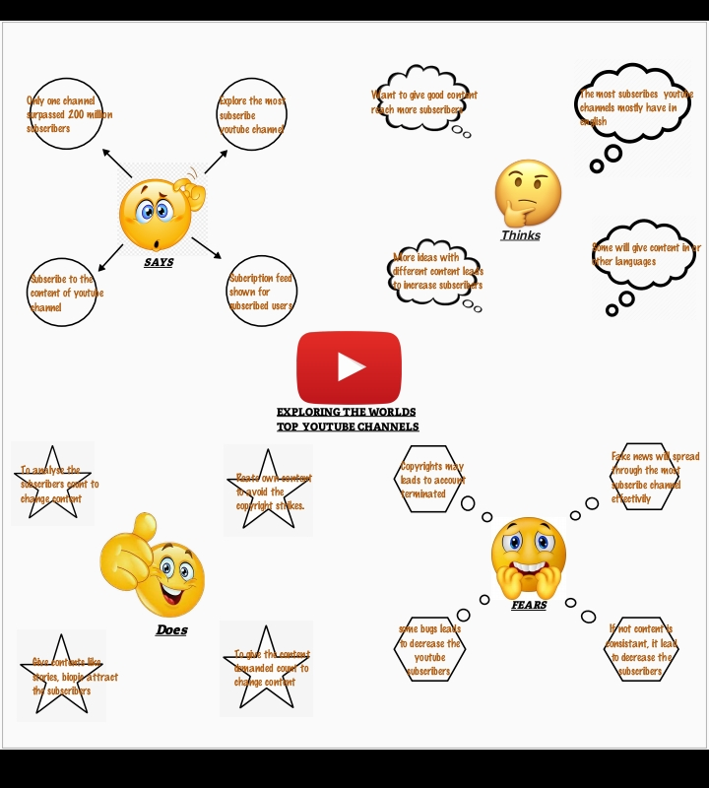

*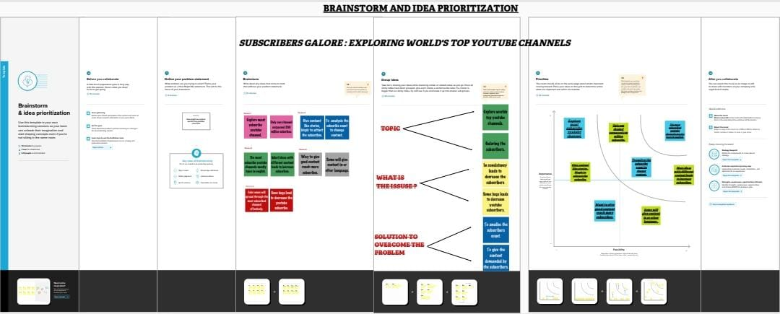****2.2: IDEATION & BRAINSTORMING MAP***

***3.RESULT :***

#Rank wise channels of youtube channels

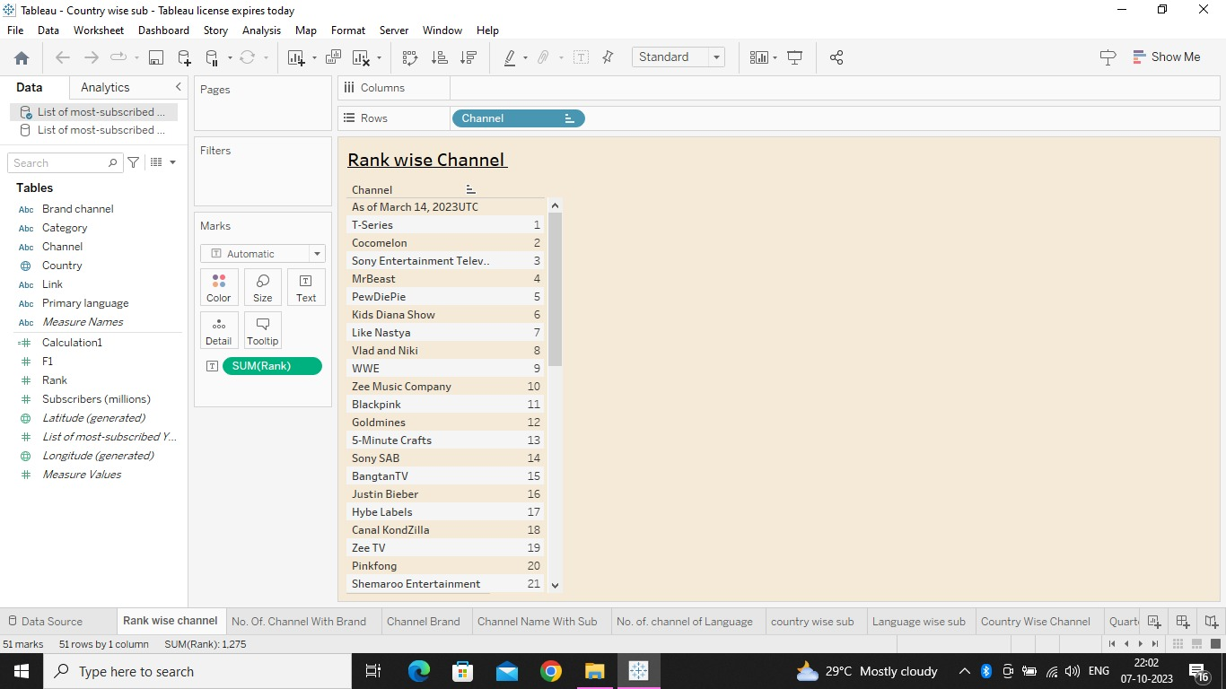

# Brand channels of youtube

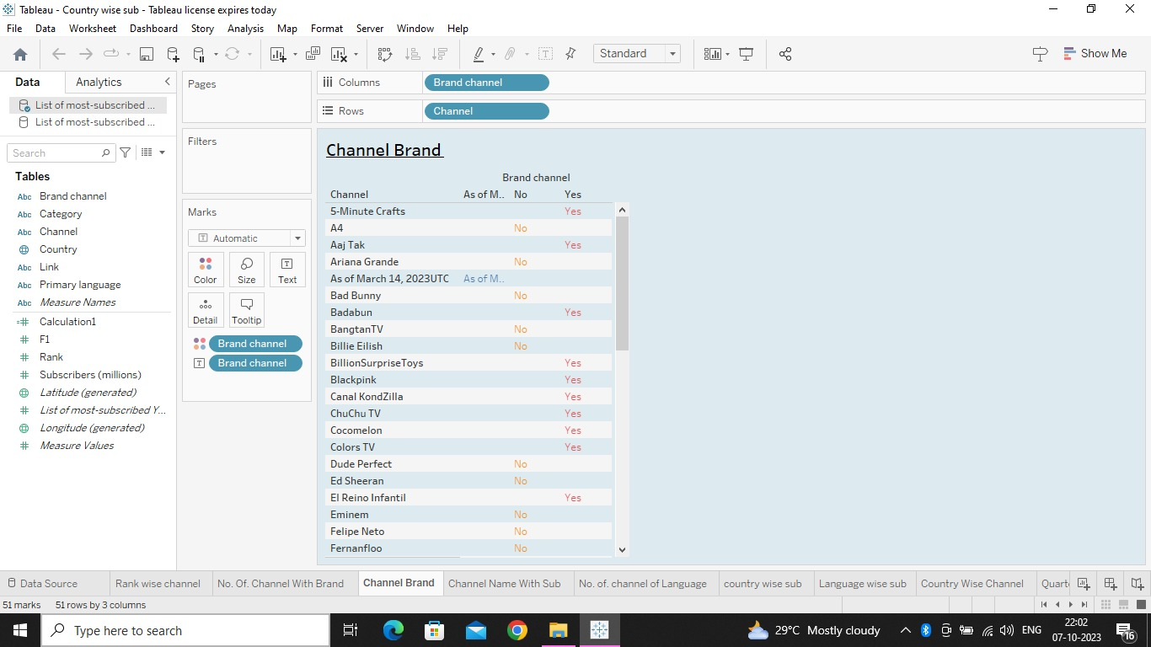

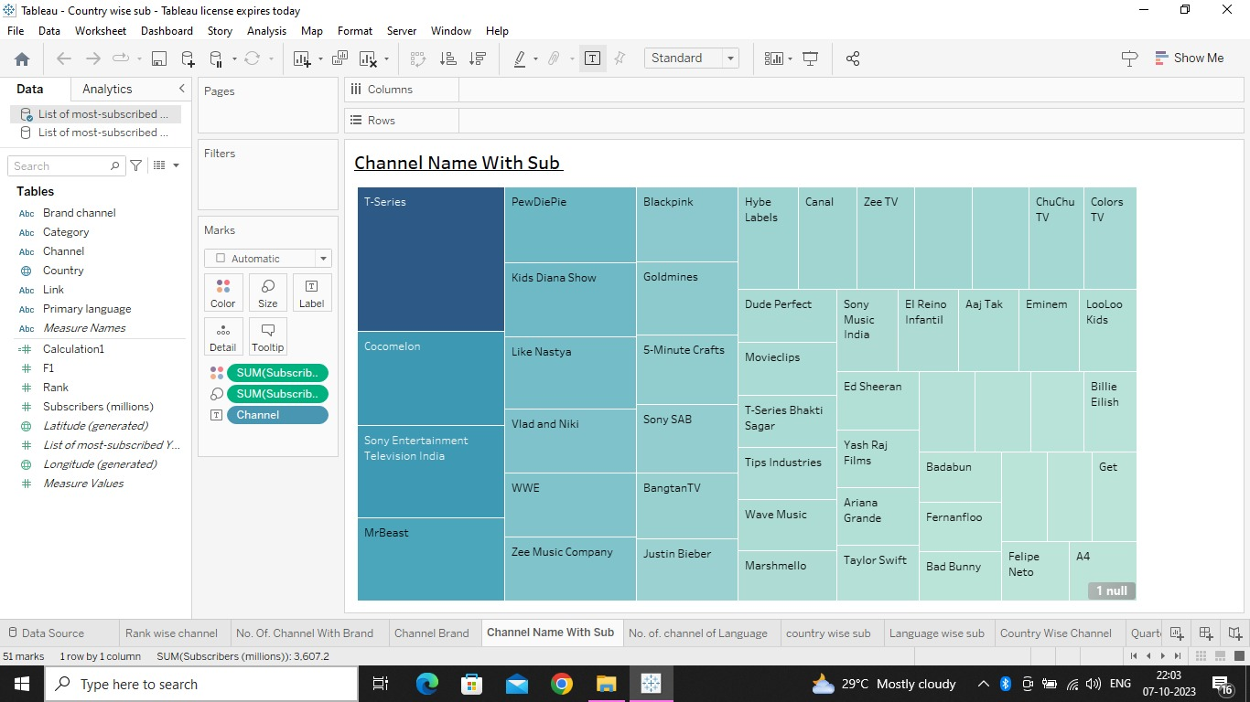#Channels Name With Sub scribers

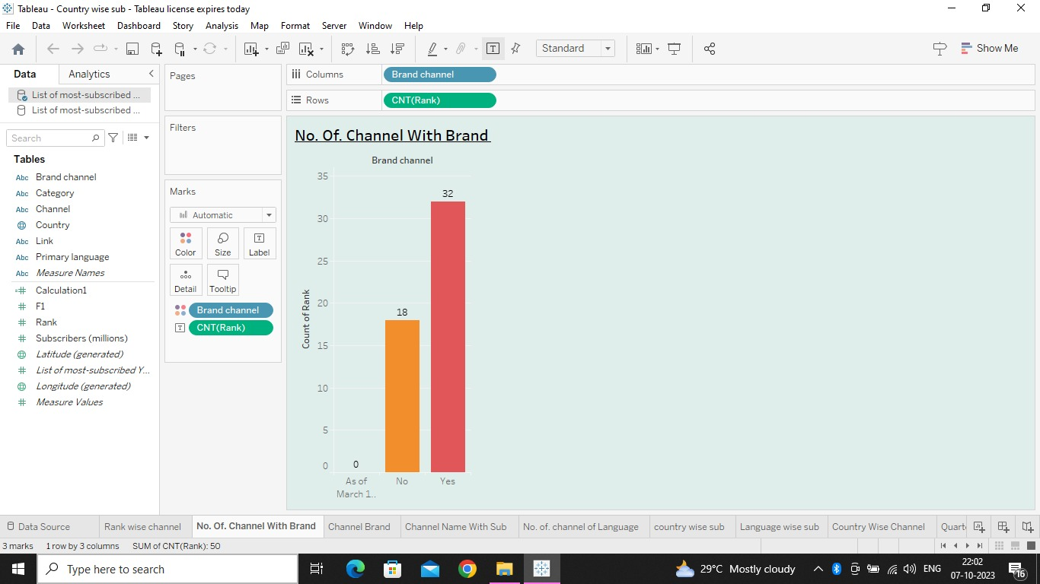#No. Of. Channels with brand

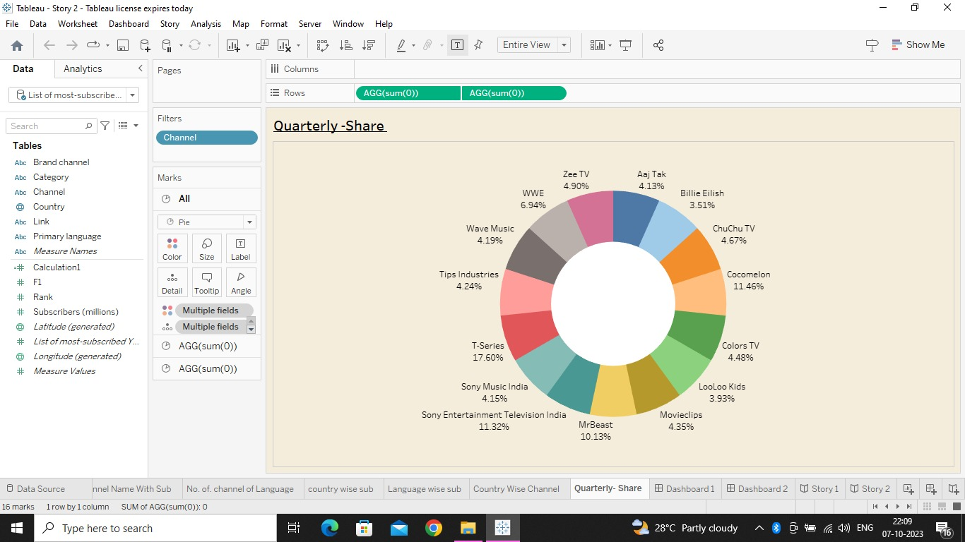# Quarterly- share of every YouTube channels

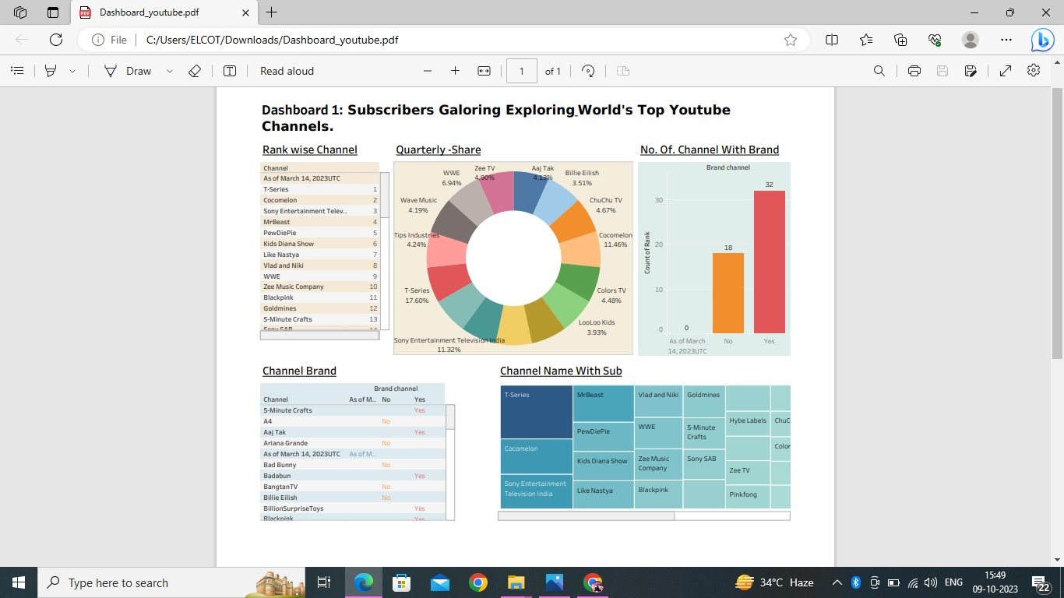***#DASHBOARD :***

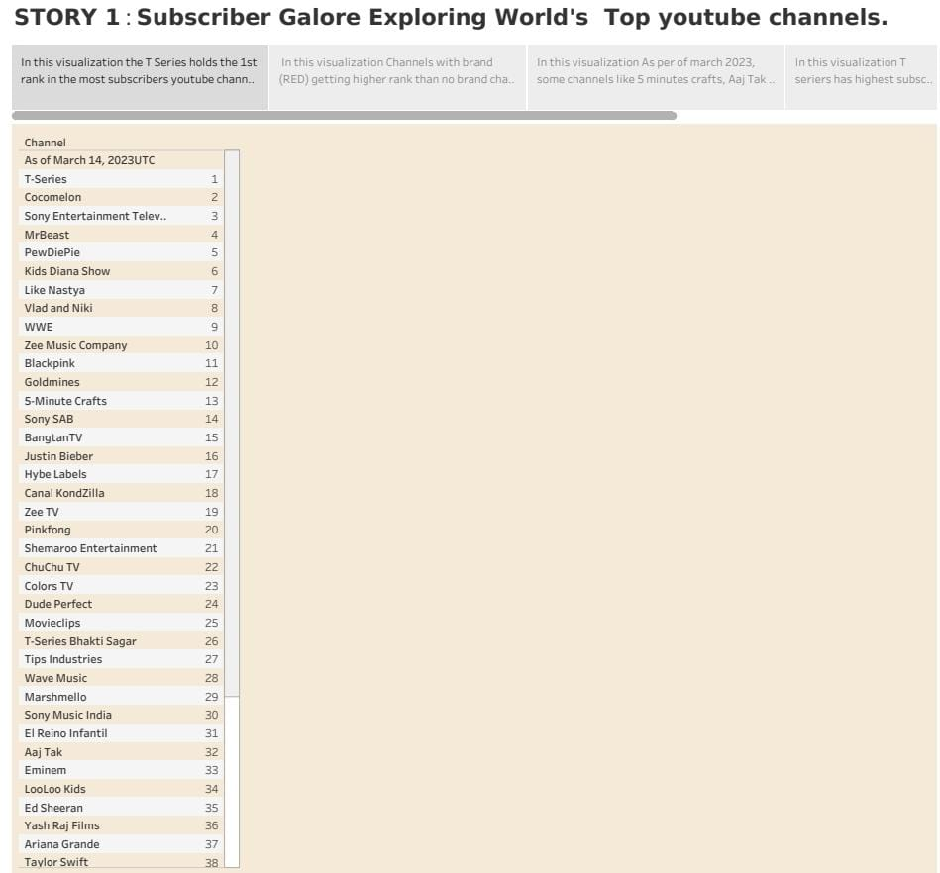***#STORY:***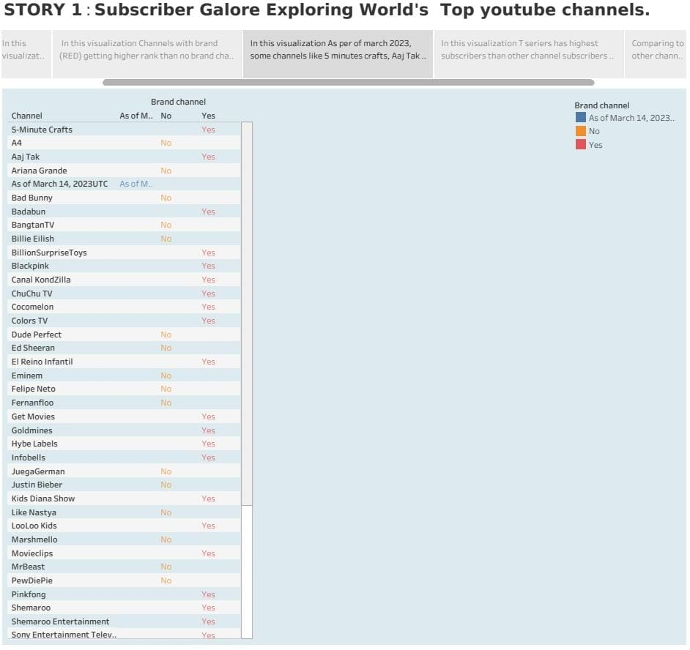

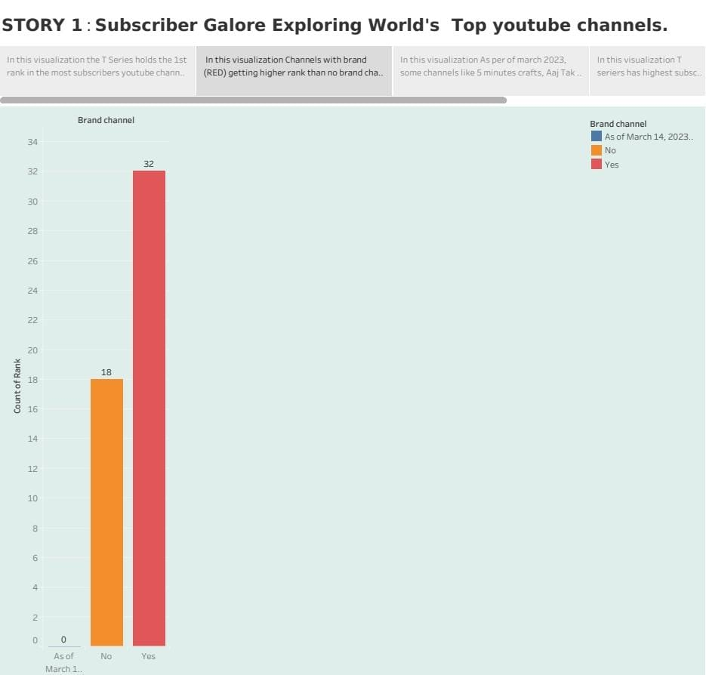

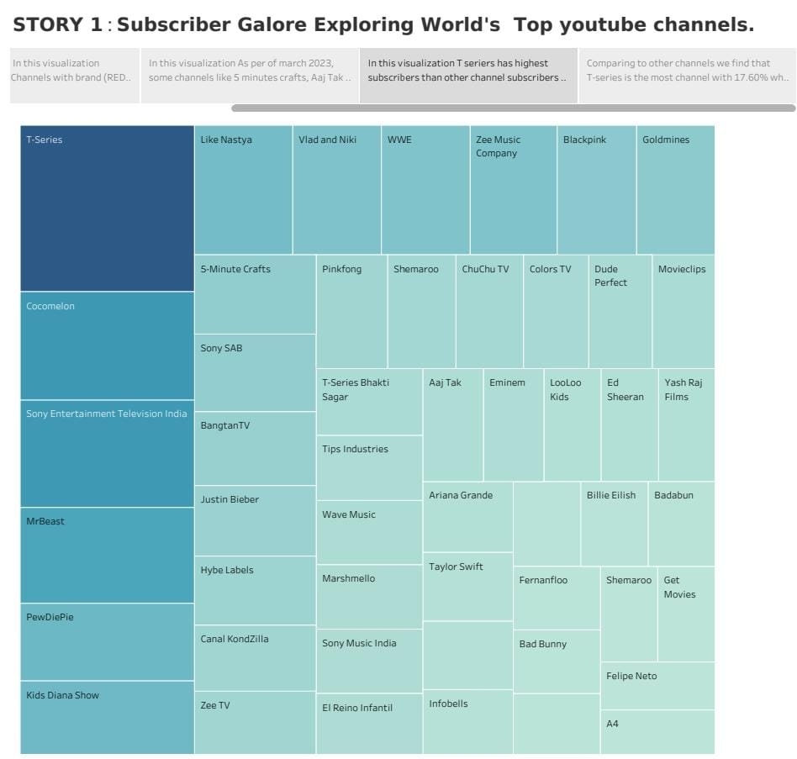

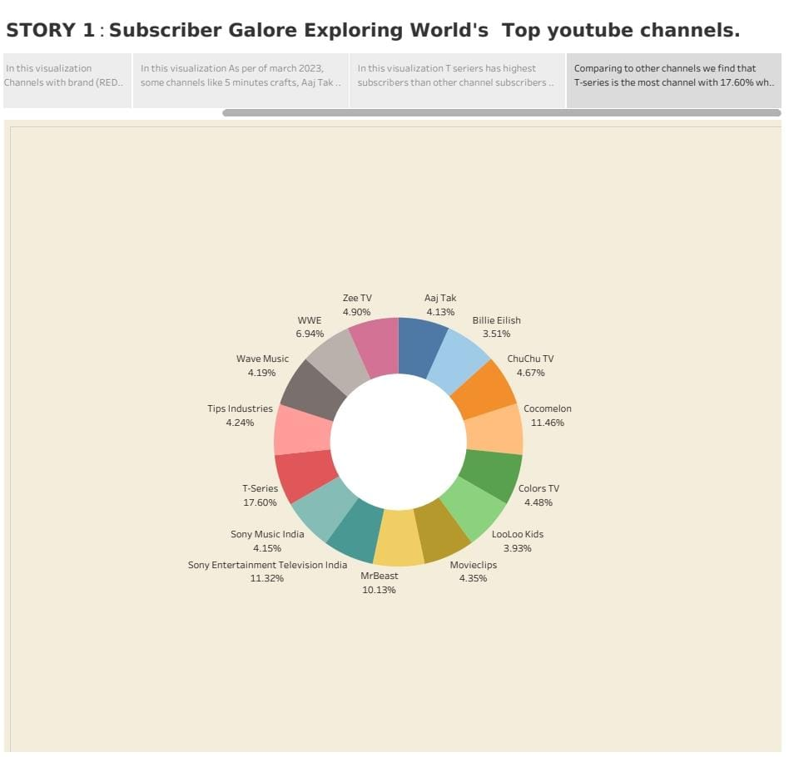

***4: ADVANTAGE & DISADVANTAGE***

***#ADVANTAGES:***

****We could explore the YouTube channels in the world

By tabluea app we create visualizations to analyse   
 data of YouTube channels subscribers.



We are learning about how to increase subscribers.



***#DISADVANTAGE :***

* Rank of the channels maybe varied.
* Branded channels have most subscribers then the unbranded channels .

***#APPLICATION :***

* Using tableau we can visualization all the data’s for easy understanding.
* By using all this data and analysing the data’s we have youtube most subscribe channel in the world .

***#CONCLUSION :***

Here by we understand how to use tableau application and analyising the given data.using tableau application we can create visualization are easy understanding.

***#FUTURE SCOPE :***

We will give the various information of the given datasets using tableau software.